Round 1 – ‘Kid’ mode

Write DML queries for the following questions

1. Display unique Jobs from EMP table

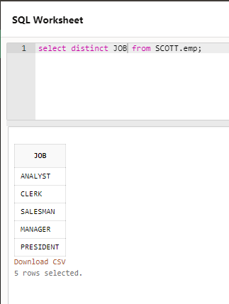

1. List the employees in the ascending order of their salaries

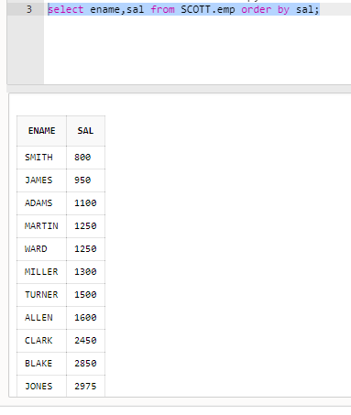 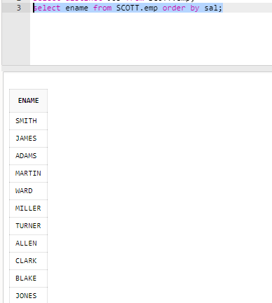

1. List the details of the employees in ascending order of the dept no and descending of Jobs

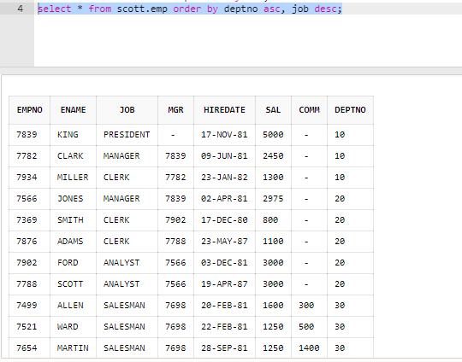

1. Display all the unique job groups in the descending order

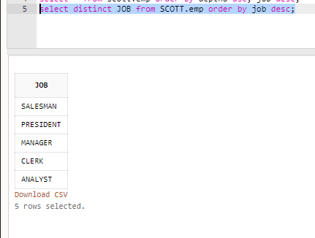

1. Display all the employees who are managers

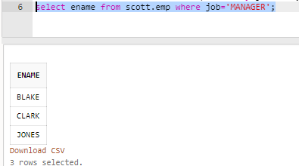

1. List the employees who joined before 1981

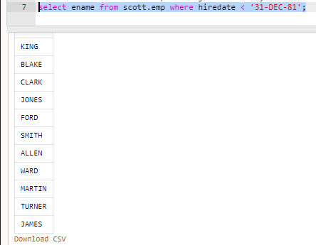

1. List the Empno, Ename, Sal, daily sal of all employees in the ascending order of annual sal

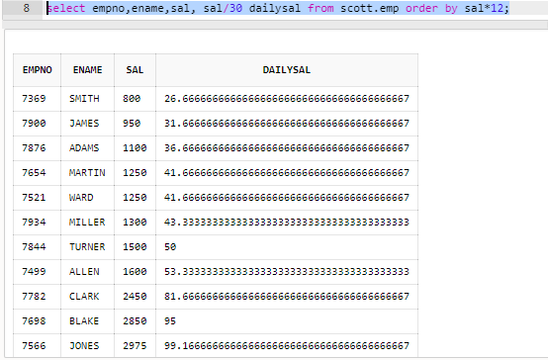

1. Display the Empno, Ename, job, Hiredate, Exp of all Mgrs

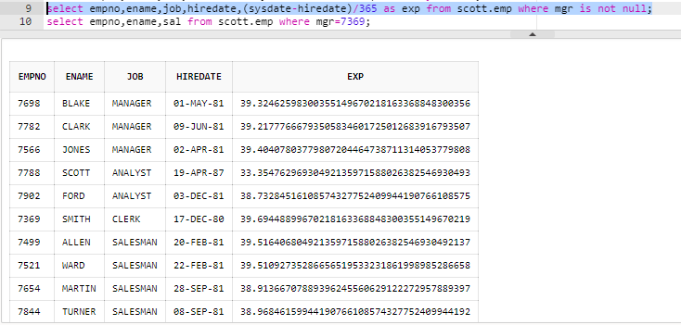

1. List the Empno, Ename, Sal, experience of all employees working for Mgr=7369

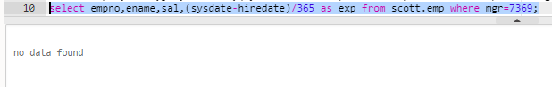

1. Display all the details of the employees whose Comm. Is more than their Sal

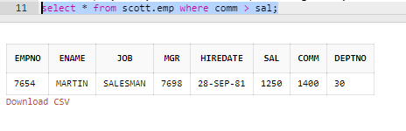

1. List the employees in the asc order of Designations of those joined after the second half of 1981

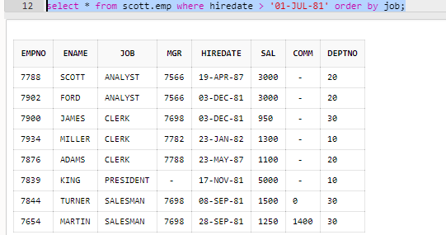

1. List the employees along with their experience and daily salary is more than Rs.100

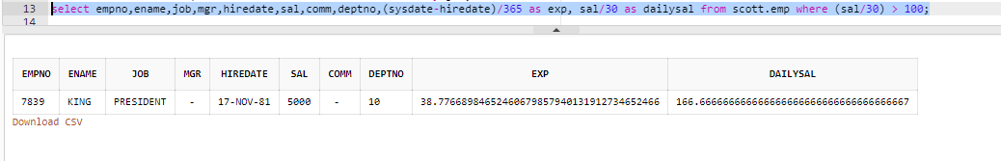

1. List the employees who are either ‘CLERK’ or ‘ANALYST’ in the Desc order

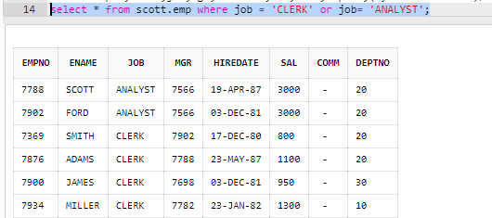

1. List the employees who joined on 1-MAY-81,3-DEC-81,17-DEC-81,19-JAN-80 in asc order of seniority

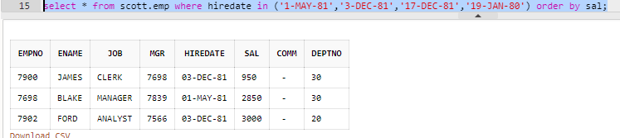

1. List the emp who are working for the Deptno 10 or 20

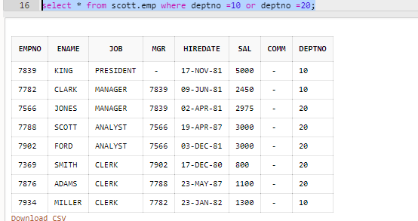

1. List the employees who are joined in the year ‘81

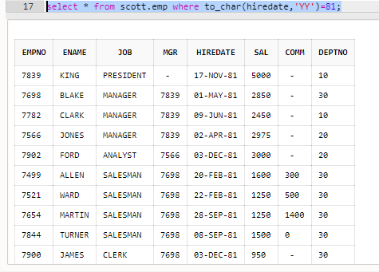

1. List the employees who are joined in the month of Aug 1980

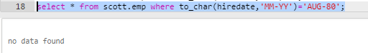

1. List the Enames those are having five characters in their Names

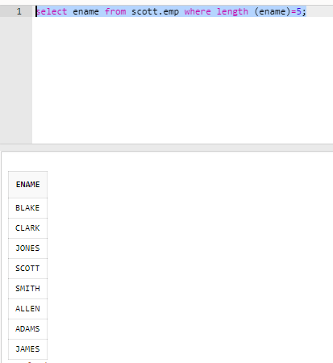

1. List the Enames those are starting with ‘S’ and with five characters

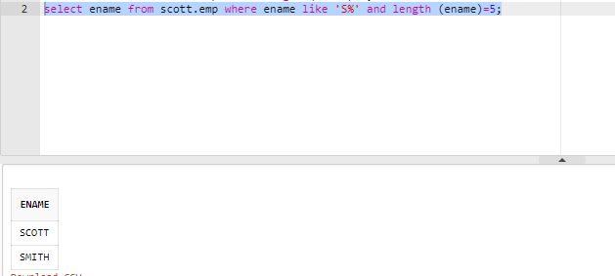

1. List the employees those are having four chars and third character must be ‘r’

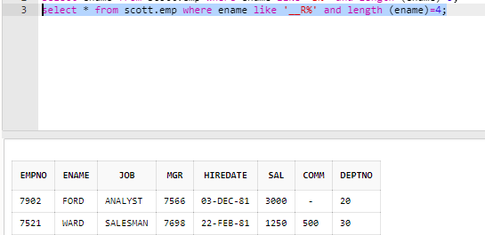

1. List the Five character names starting with ‘S’ and ending with ‘H’

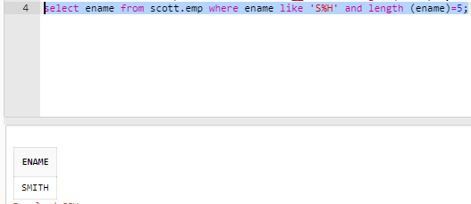

1. List the employees whose Sal is four digit number ending with Zero

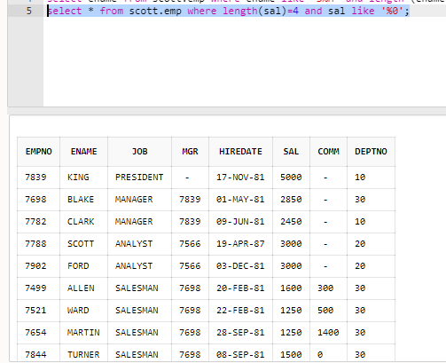

1. List the employees whose names having a character set ‘LL’ together

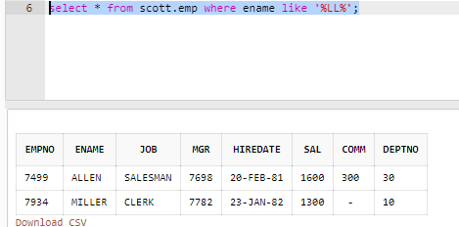

1. Display the Empno, Ename, Sal, Dname, Loc, Deptno, Job of all employees working at CJICAGO or working for ACCOUNTING dept with Ann Sal>28000, but the Sal should not be=3000 or 2800 who doesn’t belongs to the Mgr and whose no is having a digit ‘7’ or ‘8’ in 3rd position in the asc order of Deptno and desc order of job

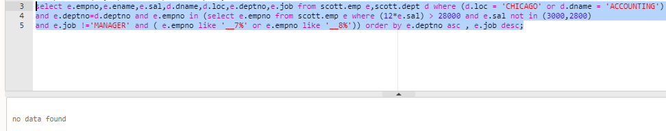

1. List the Empno, Ename, Sal, Dname, Exp, and Ann Sal of employees working for Dept10 or 20

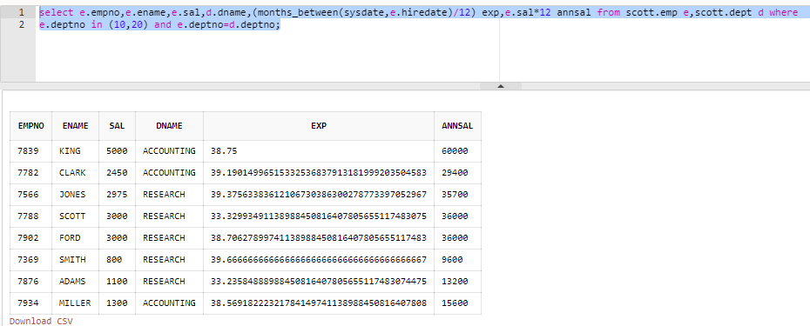

1. List the details of the employees whose Salaries more than the employee BLAKE

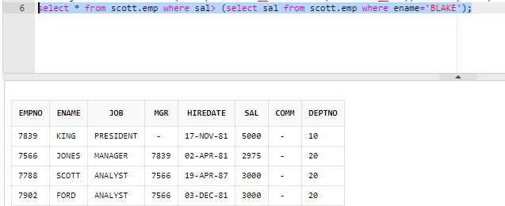

1. List the employees whose Jobs are same as ALLEN

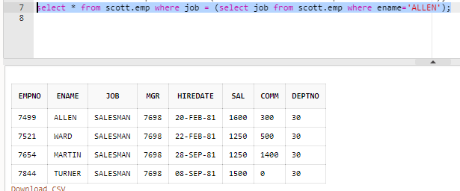

1. List the employees who are senior to King

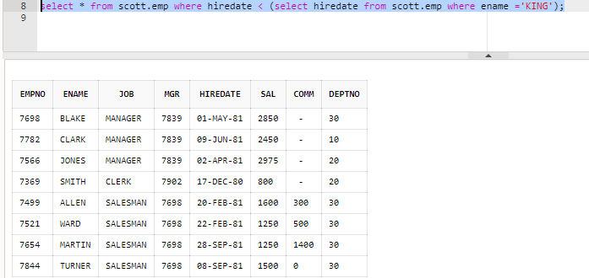

1. List the Employees who are senior to their own MGRS

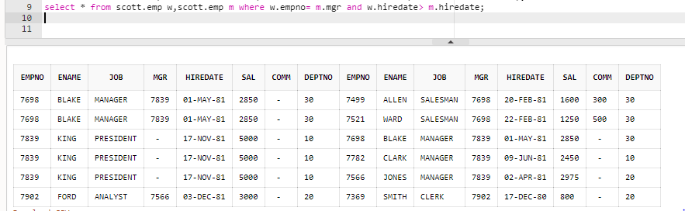

1. List the Employees of Deptno 20 whose Jobs are same as Deptno10

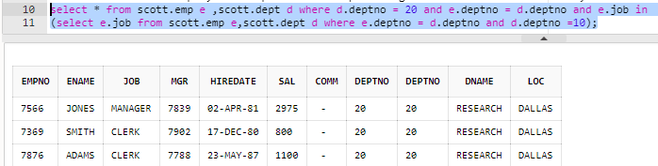

1. List the Employees whose Sal is same as FORD or SMITH in desc order of Sal

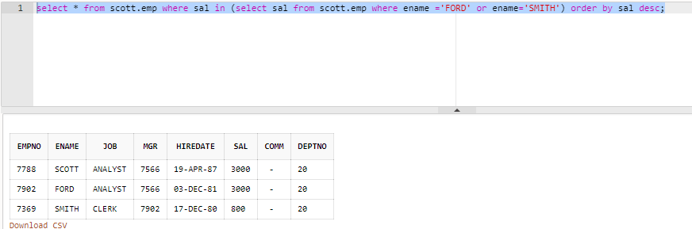

1. List the employees Whose Jobs are same as MILLER or Sal is more than ALLEN

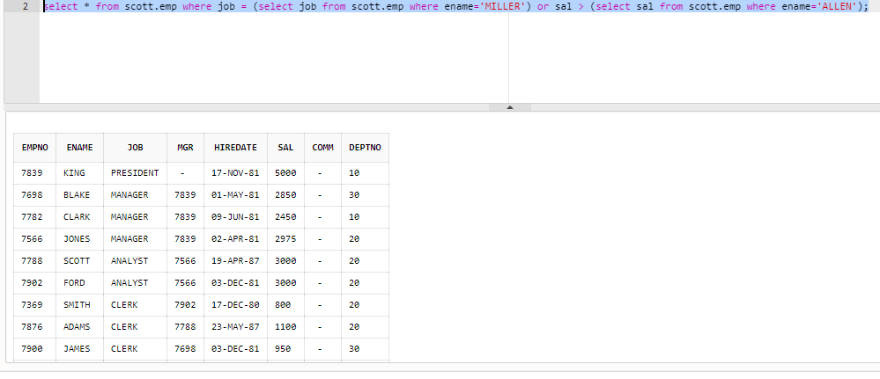

1. List the Employees whose Sal is > the total remuneration of the SALESMAN

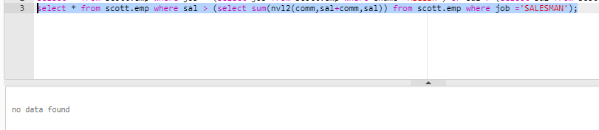

1. List the employees who are senior to BLAKE working at CHICAGO & BOSTON

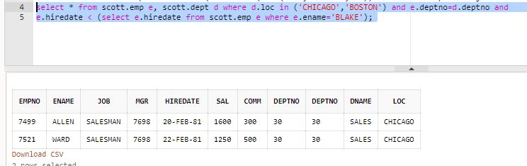

1. List the employee names and his average salary department wise

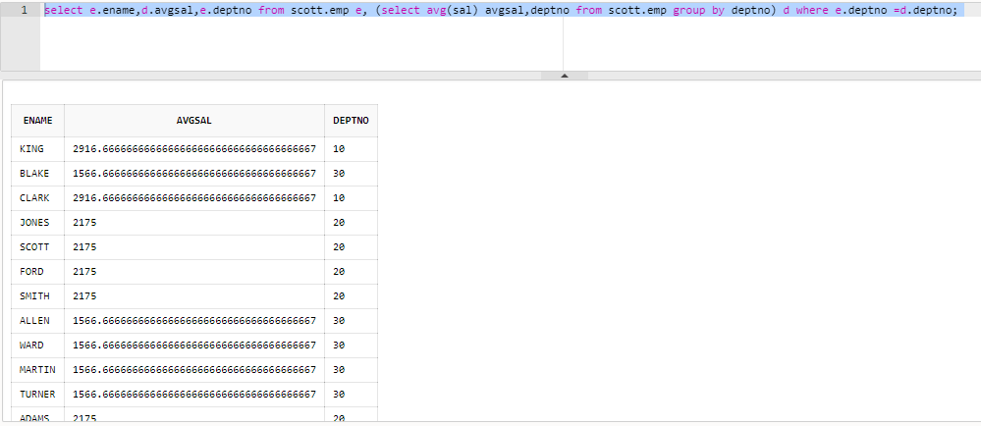

1. Find out least 5 earners of the company

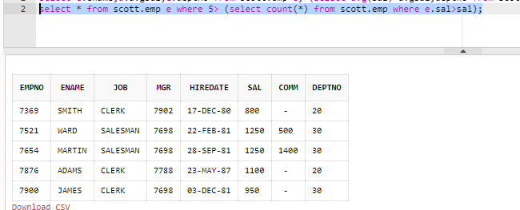

1. Find out employees whose salaries greater than salaries of their managers

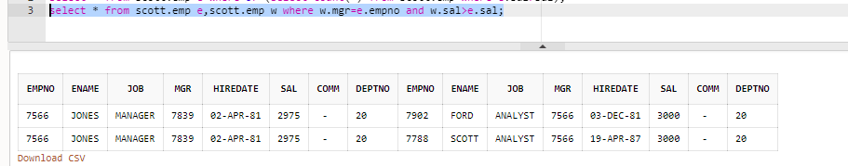

1. List the managers who are not working under the president (the manager should not be president)

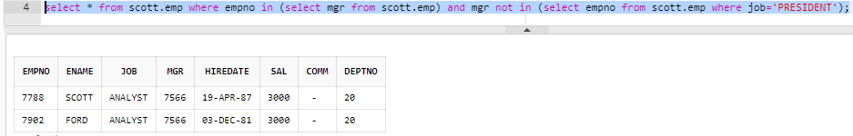

1. List the records from emp whose deptno is not in dept table

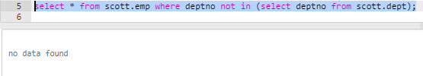

1. List the details of the employees in the ascending order of the sal

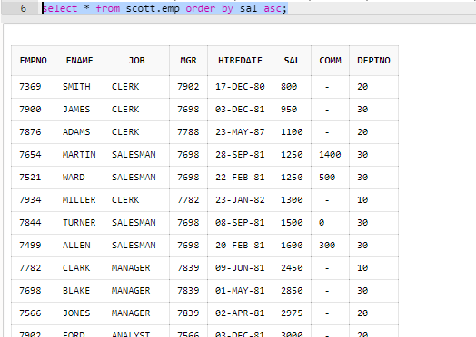

1. List the dept in the ascending order of the job and the desc order of the employees print empno, ename

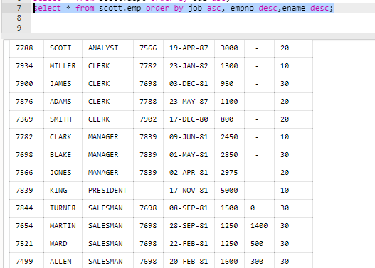

1. Display the unique dept of the employees as in employee table

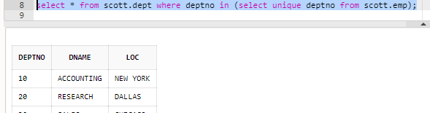

1. Display the details of the BLAKE

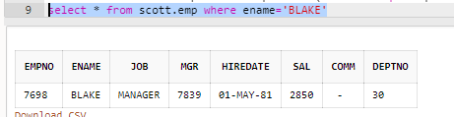

1. List the emp whose annual sal is < 25000 in the asc order of the salaries

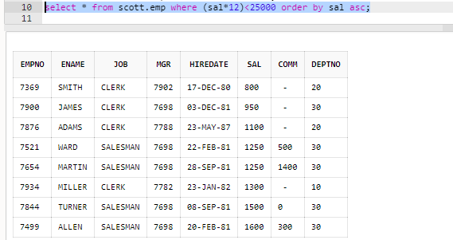

1. List the empno,ename,sal,TA30%,DA 40%,HRA 50%,GROSS,LIC,PF,net,deduction,net allow and net sal in the ascending order of the net salary

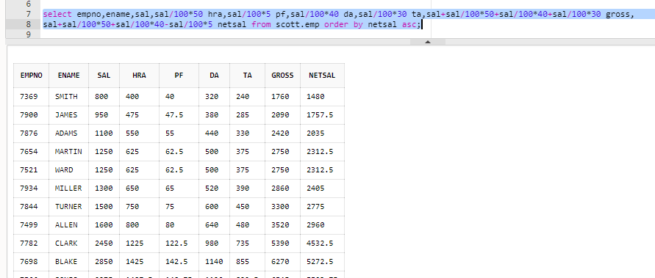

1. List all the 4 char employees

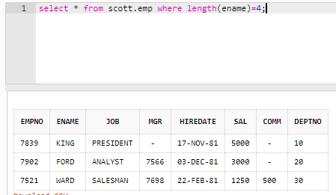

1. List the employees whose sal is ending with 00

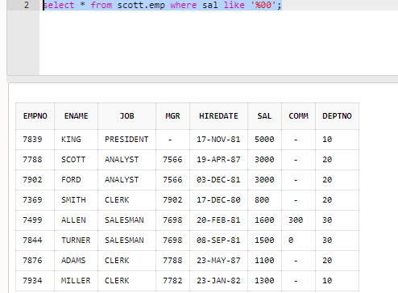

1. List employees who joined in the month having second char ‘a’

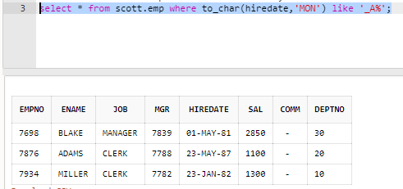

1. List the emp who are clerks who have exp more than 8yrs

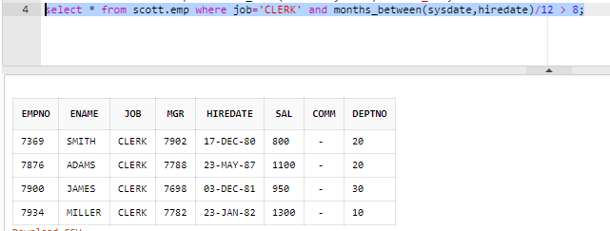

1. List the employees joined in jan with salary ranging from 1500 to 4000

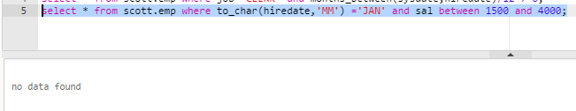

1. List the employees along with exp of those working under the mgr whose number is starting with 7 but should not have a 9 joined before 1983

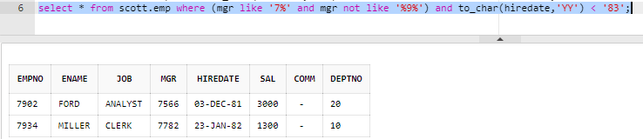

1. List the employees who are working as either mgr or analyst with the salary ranging from 2000 to 5000 and without commission

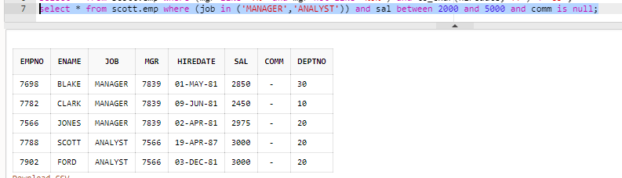

1. List the empno,ename,sal,job of the employees with /ann sal <34000 but receiving some comm. Which should not be>sal and designation should be sales man working for dept 30

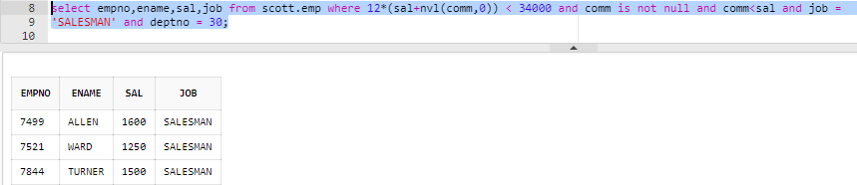

1. List the empno,ename,sal,job,deptno&exp of all the employees belongs to dept 10 or 20 with an exp 6 to 10 y working under the same mgr with out comm. With a job not ending irrespective of the position with comm.>200 with exp>=7y and sal<2500 but not belongs to the month sep or nov workingunder the mgr whose no is not having digits either 9 or 0 in the asc dept& desc dept
2. List the details of the employees working at Chicago

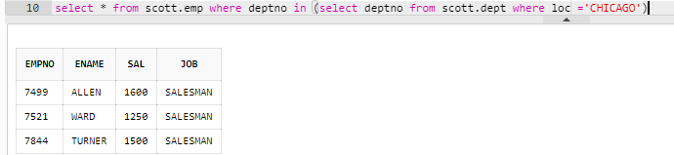

1. List the empno, ename, sal, loc of the employees working at Chicago dallas with an exp>6ys

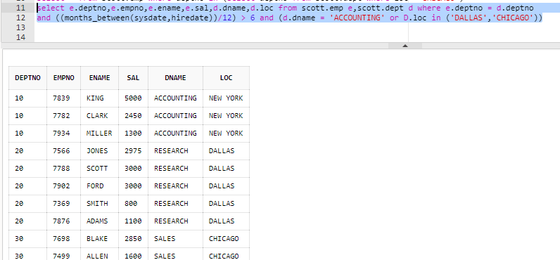

1. List the employees along with loc of those who belongs to dallas ,newyork with sal ranging from 2000 to 5000 joined in 81

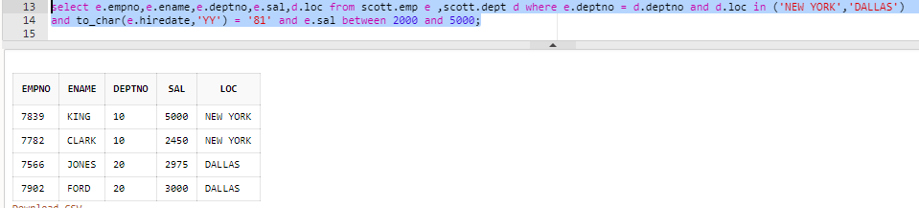

1. List the employees who are senior to MILLER

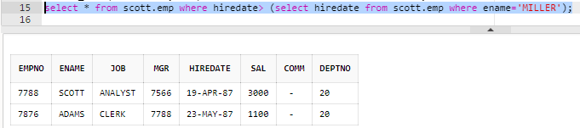

1. List the total salary, maximum and minimum salary and average salary of the employees deptno wise, for department 20 and display only those rows having an average salary > 1000

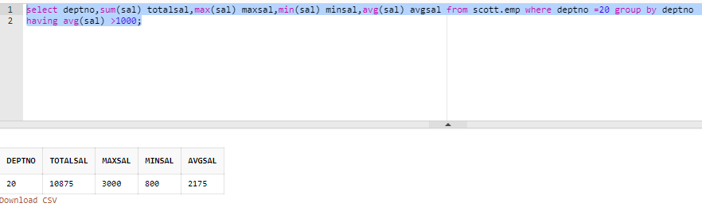

1. Display the name and employee number of the employee who is earning the second highest salary

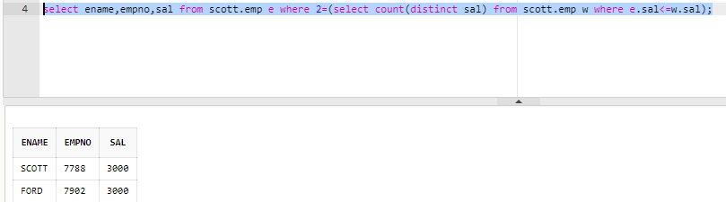

1. List the department number and total salary payable in each department

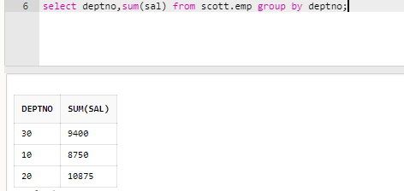

1. List names of employees who are more than 2 years old in the company

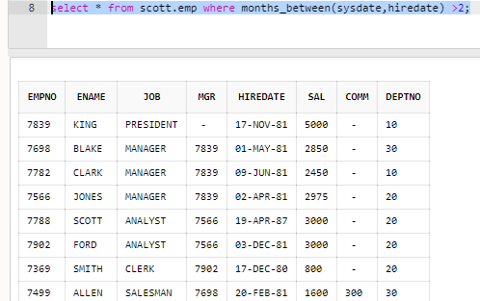

1. List the maximum salary paid to a salesman

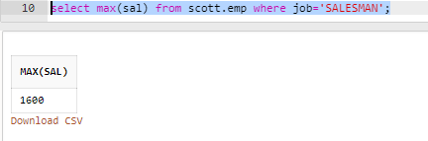

1. List the name of the employee and designation of the employee who does not report to anybody

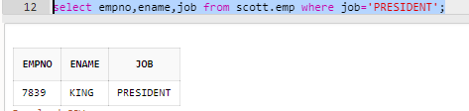

1. List the total salary, maximum and minimum salary and average salary of the employees, for department 20.

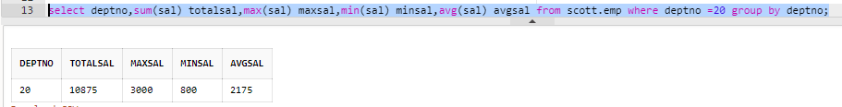

1. List employees whose job is same as that of Smith

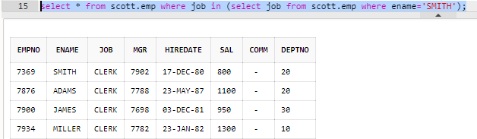

1. List employee getting the max salary

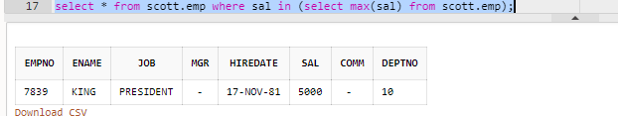

1. List all managers

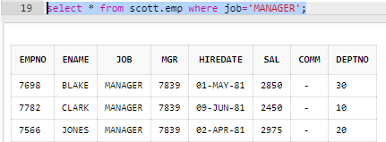

1. List employees who are not managers

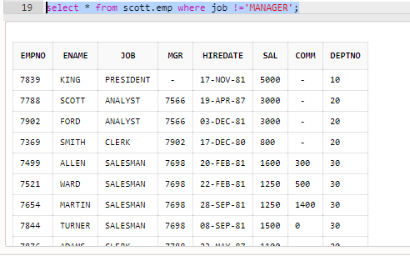

1. List all employees who earn more than the average salary in their department

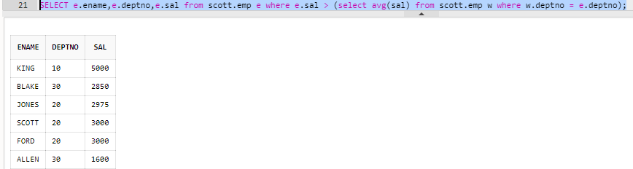

1. List employees whose salary is greater than their manager’s salary

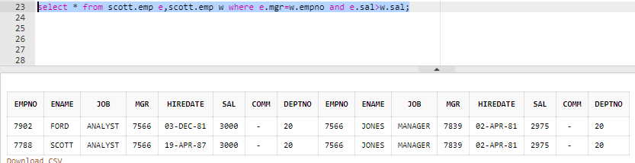

1. List employees who work in Research department

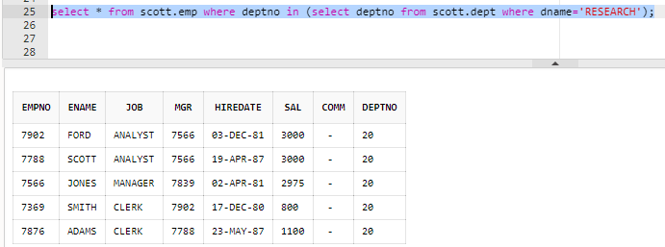

1. List name, salary and PF amount of all employees. (PF is calculated as 10% of basic salary)

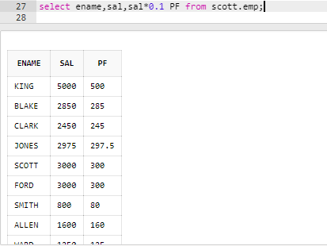

1. List the employee names of analysts and salesmen.

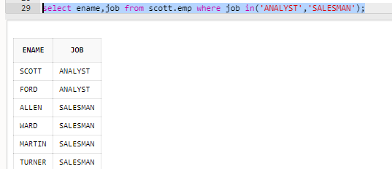

1. List the names of those employees whose employee numbers are 7369, 7521, 7839, 7934, 7788.

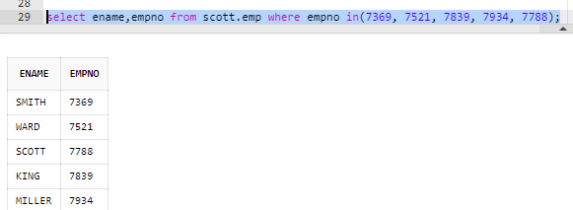

1. List those employees who do not belonging to department 30, 40, or 10.

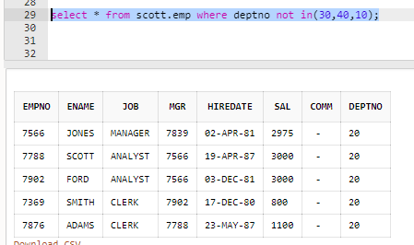

1. List those employee names who have joined between 30 June and 31 Dec ‘81.

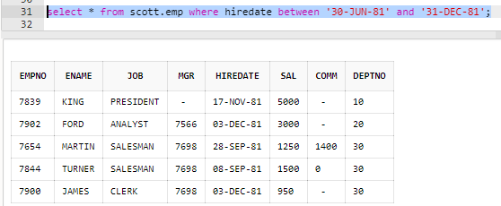

1. List the different designations available in the company

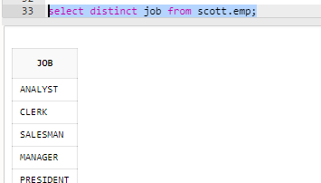

1. List those employees name that are not eligible for commission

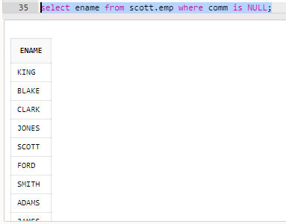

1. List the name of the employee and designation of the employee who does not report to anybody

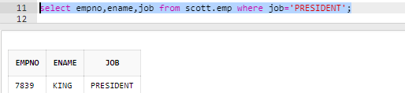

1. List the employees who are eligible for commission

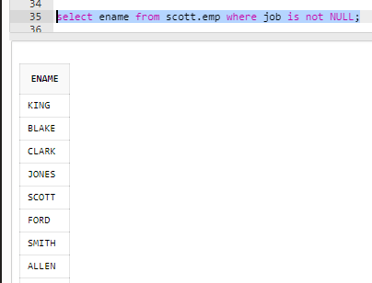

1. List names of employees if the names have “i” as the second character

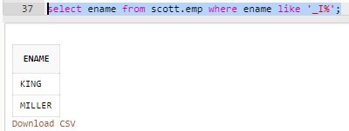

1. Display the names of all employees with their salary and commission earned. Employees with a null commission field should have 0 in the commission column

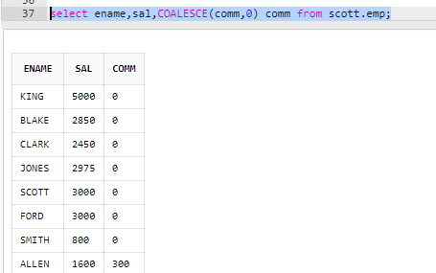

3.2 Round 2 – Group by clause

Write queries for the following questions

1. List the count and average salary for employees in department 20.

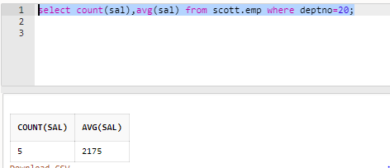

1. List names of employees who are older than 30 years in the company.

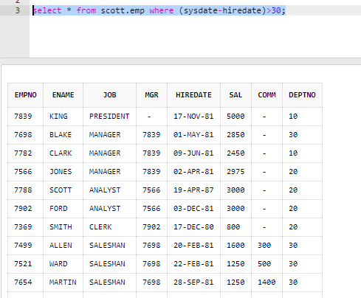

1. List the employee name , hire date in the descending order of the hire date.

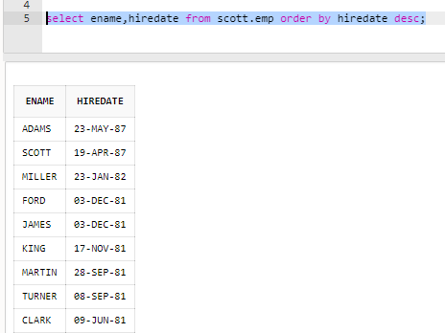

1. List employee name, salary, PF, HRA, DA and gross; order the results in the ascending order of gross. HRA is 50% of the salary and DA is 30% of the salary.

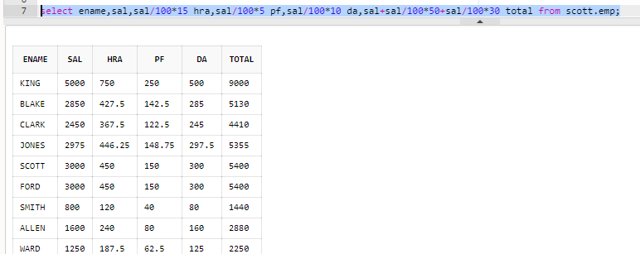

1. List the department numbers and number of employees in each department.

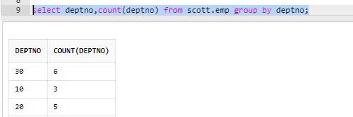

1. List the department number and total salary payable in each department.

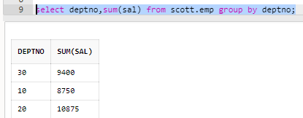

1. List the jobs and number of employees in each job. The result should be in the descending order of the number of employees.

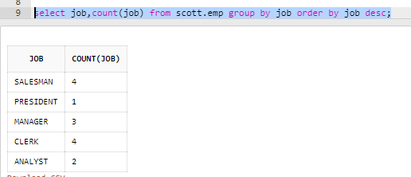

1. List the total salary, maximum and minimum salary and average salary of the employees jobwise.

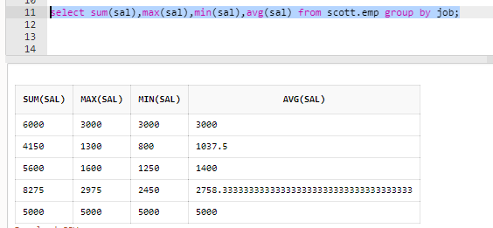

1. List the total salary, maximum and minimum salary and average salary of the employees, for department 20.

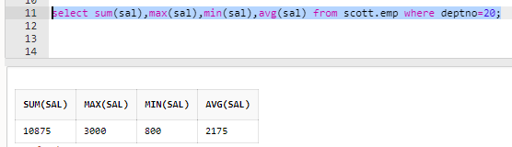

1. List the average salary of the employees job wise, for department 20 and display only those rows having an average salary > 1000

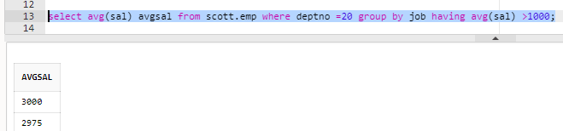

3.3 Round 3 – SUBQUERIES

Write queries for the following questions

1. List employees whose job is same as that of Smith

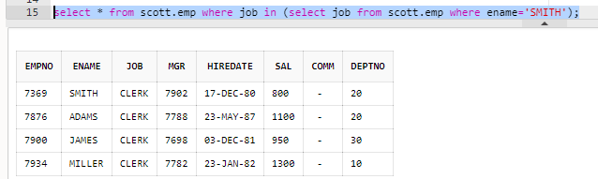

1. List employees who have joined after Adam

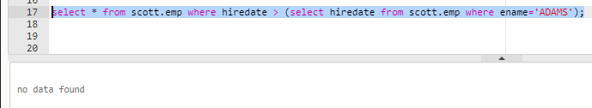

1. List employees who salary us greater than Scott’s salary

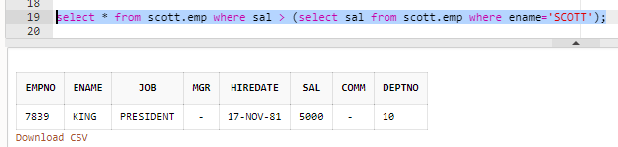

1. List employees getting the max salary

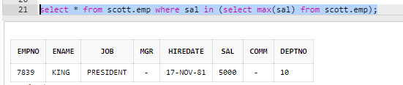

1. List employees show salary is > the max salary in deptno 30

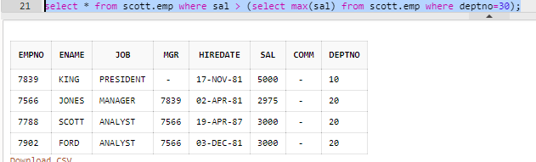

1. List all employees whose department and designation is same as that of employee with empno 7788.

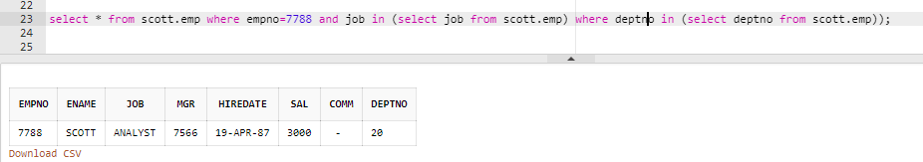

1. List employee who are not managers

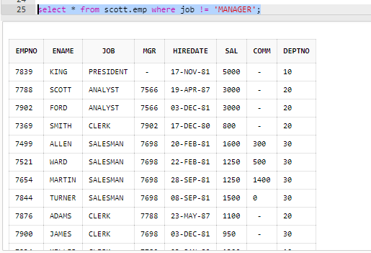

1. List all managers

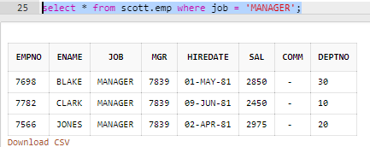

1. List all employees who earn more than the average salary in their department

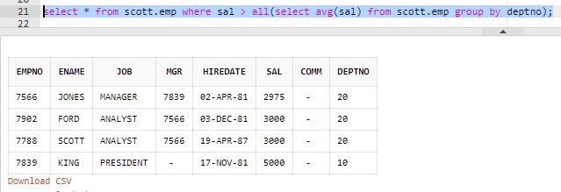

1. List employees whose salary is greater than their manager’s salary

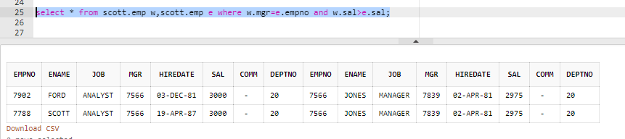

1. List departments with no employees

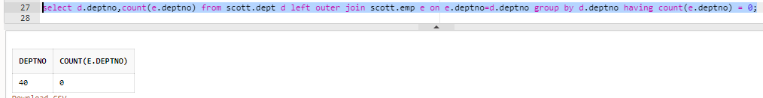

3.4 Round 4 – Joins (Mortal mode)

1. List employee name, department number and their corresponding department name.

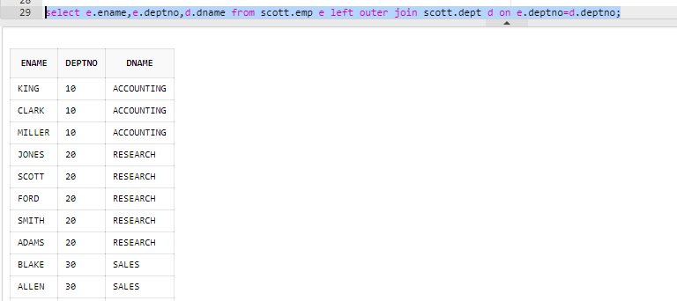

2. List employee name and their manager name

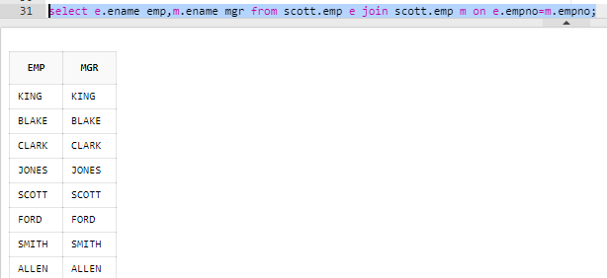

3. List employees who work in Research department

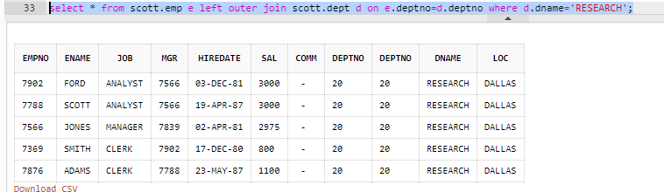

4. List all rows from EMP table and only the matching rows from DEPT table.

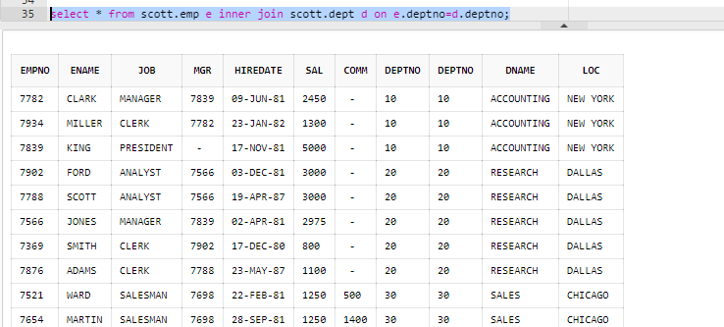

5. List all rows from EMP table and only the matching rows from DEPT table.



6. Write a query to perform full outer join between EMP and DEPT tables

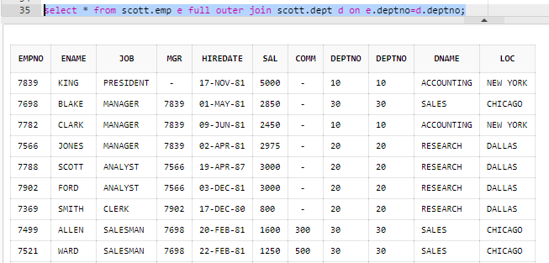

7. List employee name, their manager name and managers manager nam

